**Texas A&M University-Commerce**

**Marketplace/Touchnet Report**

**How to run a Marketplace Report:**

* 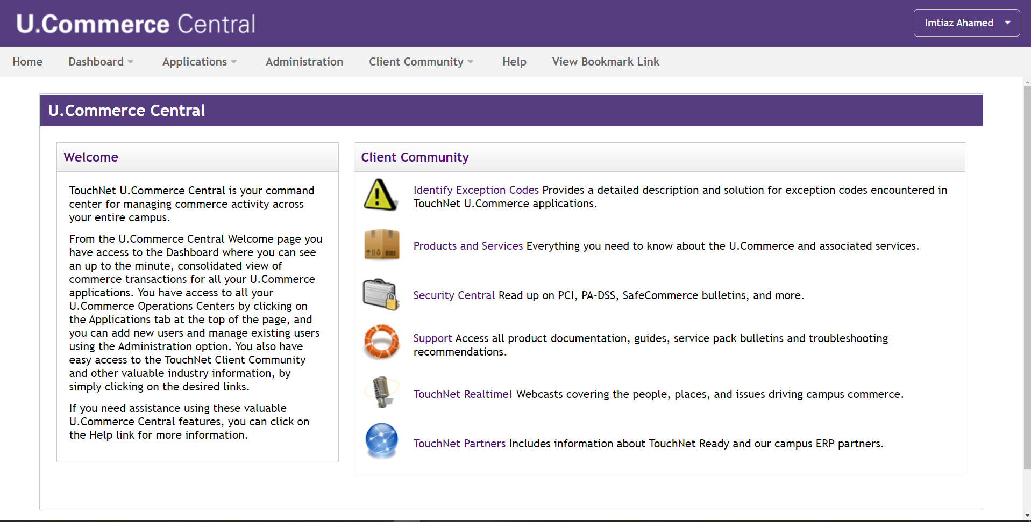Step 01**: *Login To Touchnet/Marketplace (u.Commerce Central)***
* Step 02: ***Click Application > Marketplace > Marketplace Report > Store> Study Abroad Payment (your desired store) > By Products >***

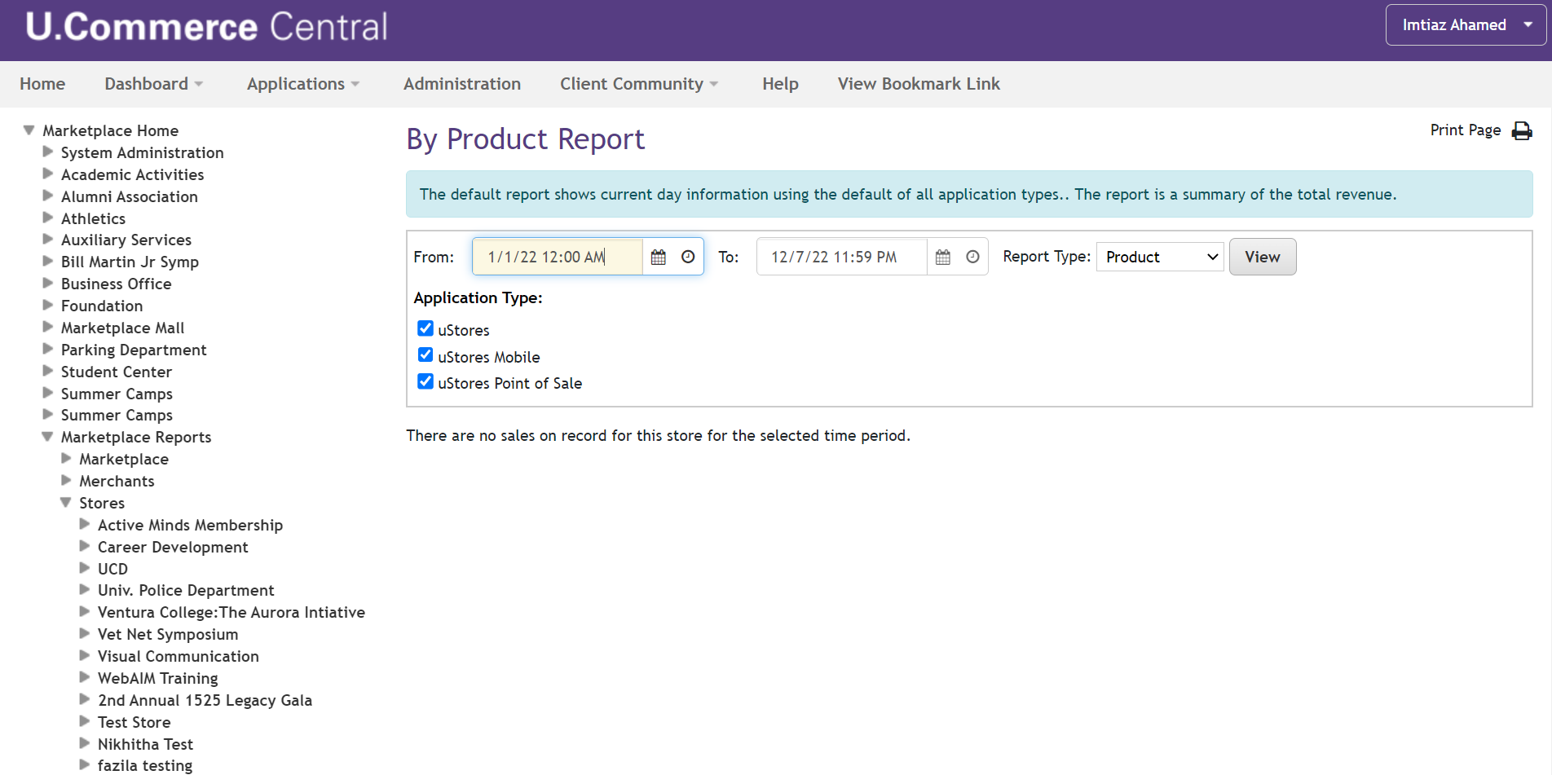



* Step 03: ***Select a Time Range > click View > Check Box Italy (your desired product out of store) > View Multiple Product Detail Report >***

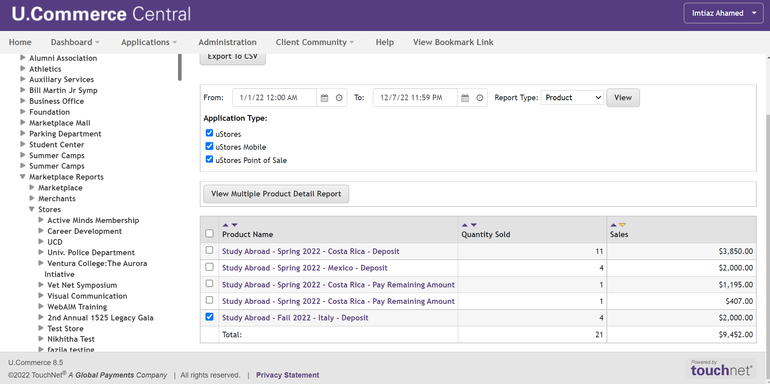

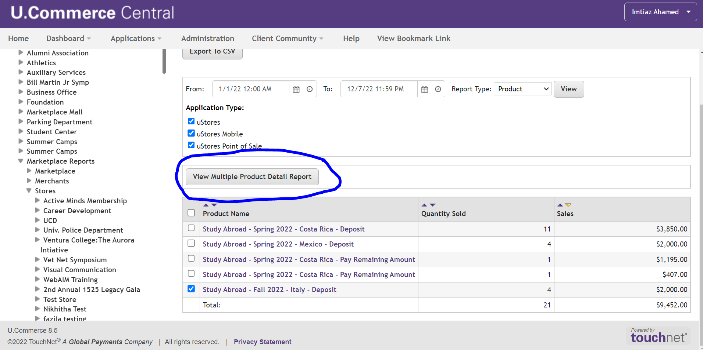

* 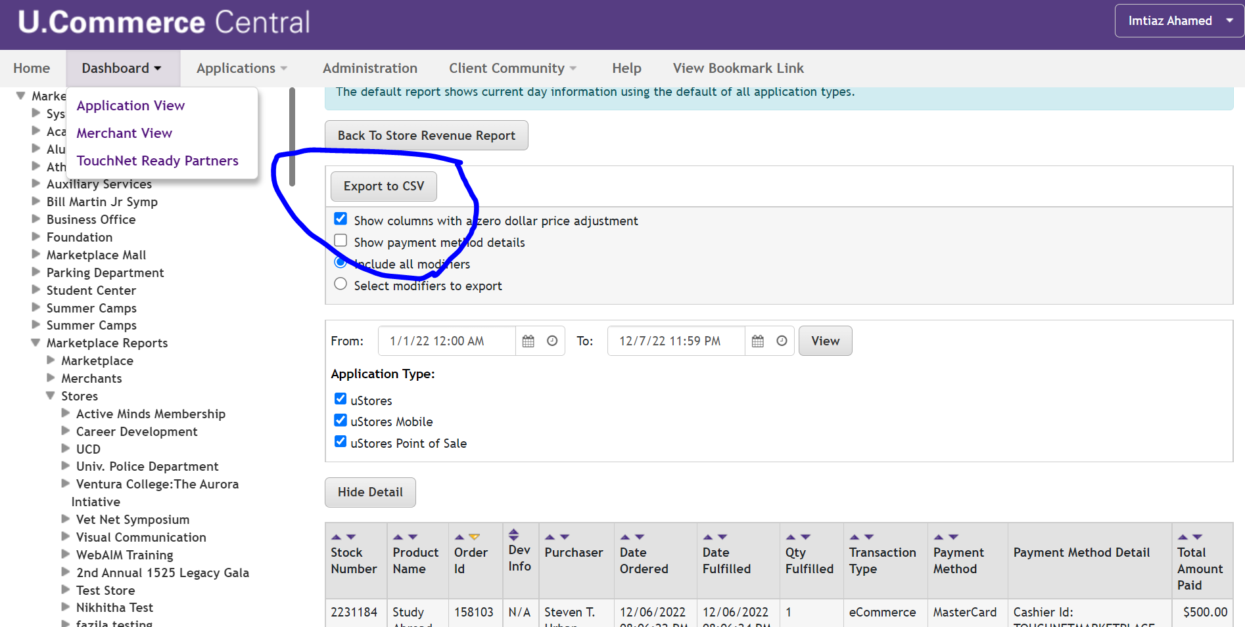***Step 04: Export to CSV***

**NOTE:** Marketplace Reports can be generated in several formats, By Products, By Revenue, By Payment Type, By Merchant and other, It depends on Users what criteria best fits their report.

**MARKETPLACE ADMINISTRATORS**

**For any issue regarding Marketplace, Touch base with:**

|  |
| --- |
| **Jon Puttonen, BSMS** |
| *Senior Business Analyst* | *Oracle Database Administrator* | *Banner Administrator* |
| Financial Services  |  Business Administration, 190 |
| P: 903.468.3137 |

|  |
| --- |
| **Imtiaz Ahamed, BBA, MBA, MSBA**  Business Analyst |
|  |
| Financial Services  |  Business Administration, 170 | F  P: 903.886.5053 |